Product Inventory Management System
Team Members
Kaviya.M
Merlin.TG
Karen.S
Kiruthika.S
Project Execution:
Execution Steps;
- Open terminal in server folder.
- Make sure you have a start script in the package.js file.
Run:
npm start

3. Register:
The register functionality allows new users to create an account by submitting their details, which are validated and securely stored with a hashed password. It ensures unique user creation before granting access to the system.
Console should display:
Server running on PORT
Database Connected

API Testing :
Use Thunder Client to test APIs:
Test APIs:
Register User:
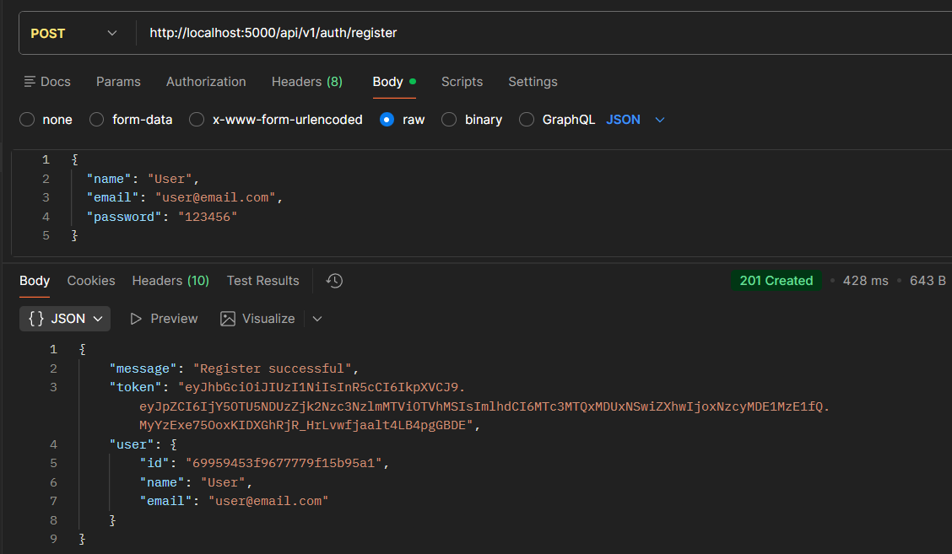
Register:
The register functionality allows new users to create an account by submitting their details, which are validated and securely stored with a hashed password. It ensures unique user creation before granting access to the system.

Login User
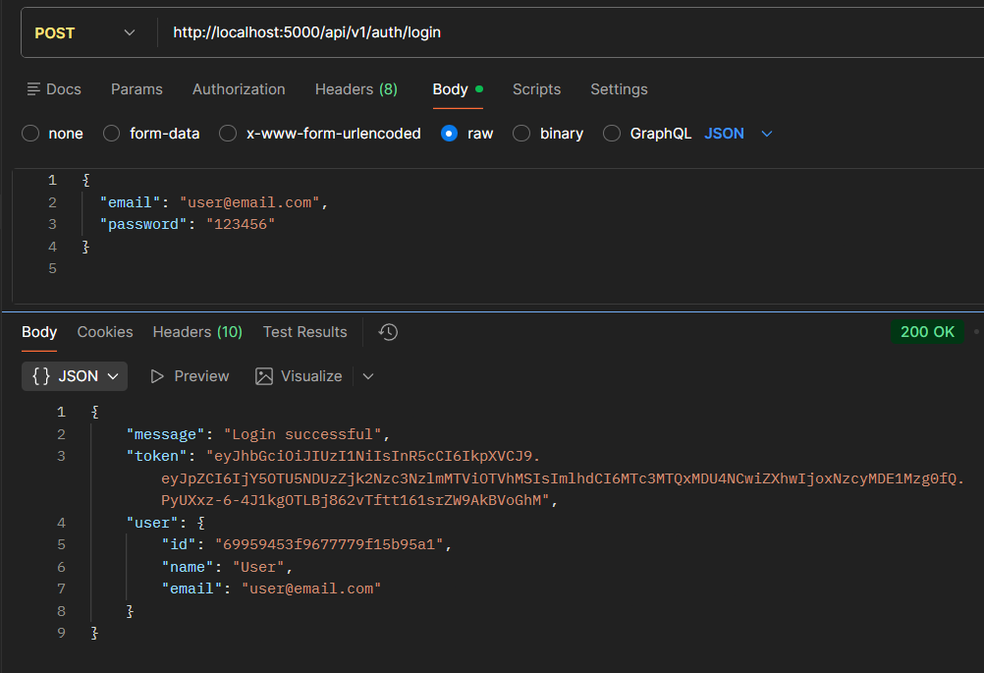
Login:
The login functionality verifies user credentials generates a JWT token upon successful authentication. This token is used to access protected routes securely.

Create Product;
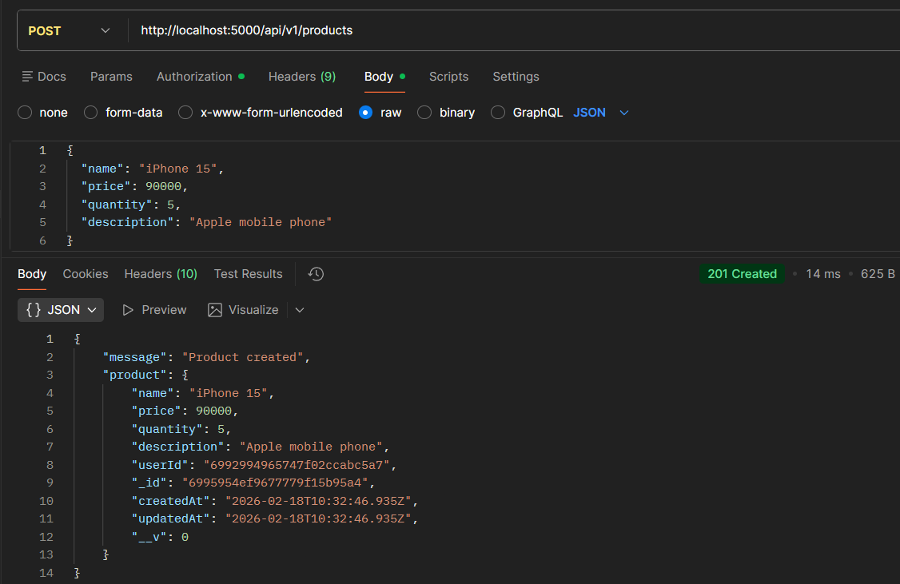
Create Product:
Allows an authenticated user to add a new product to their inventory by submitting product details. The product is saved with the user’s ID to maintain ownership.
Get all Products
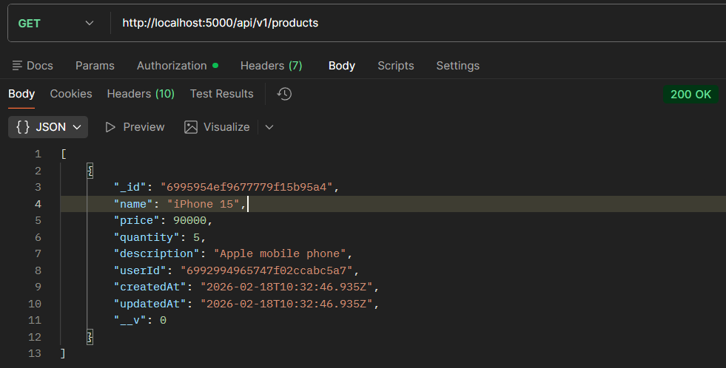
Get all Products:
Fetches all products that belong to the logged-in user. It ensures users can view only their own inventory data.
Update Product;
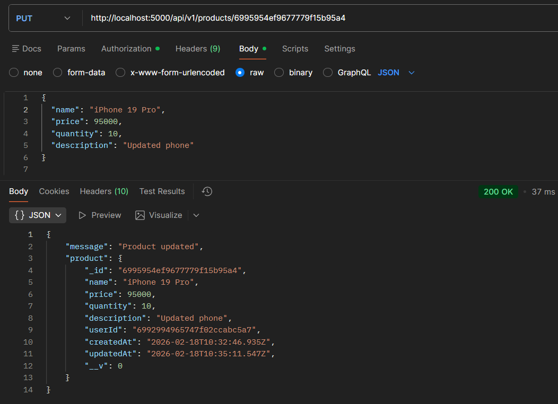
Update Product:
Enables users to modify existing product details such as name, price, or quantity. The system verifies ownership before allowing any updates.

Delete Product
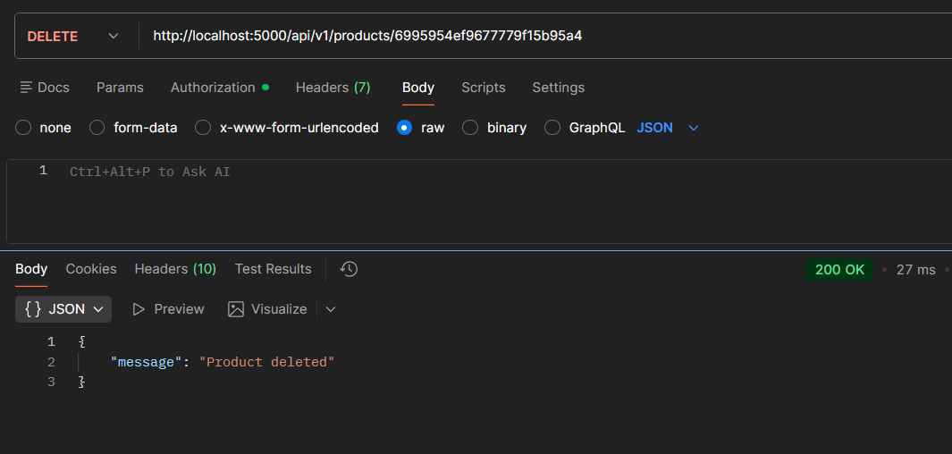
Delete Product:
Allows users to permanently remove a product from their inventory. The operation is protected to ensure only the product owner can delete it.
Conclusion:
Product Inventory Management is an important system used to track, manage, and organize products in a business. It helps businesses know how many products they have, when to restock items, and which products are selling the most. By using an inventory management system, companies can reduce errors, save time, and improve efficiency. It also helps prevent overstocking and shortages. Overall, product inventory management plays a key role in maintaining smooth business operations and ensuring customer satisfaction.

